**Anthrax Myths & Facts**

1. **Calhoun*, D. Pollard, R. Marshall**

**Southern University A&M College, Baton Rouge, LA 70813**

## C:\Users\dana.pollard\AppData\Local\Microsoft\Windows\INetCache\Content.MSO\9788B1D.tmp cid:e5159116-8dc6-4eab-8d4a-599816e70b63

*“Grow jAGs”*

*“Linking Citizens of Louisiana with Opportunities for Success”*

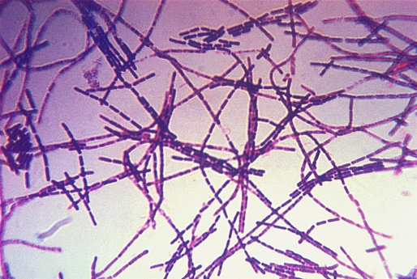

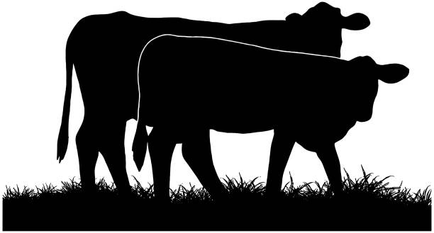

**Myth: Anthrax only affects humans.**

**Fact**: Anthrax can affect a variety of animals, including cattle. Anthrax is most associated with herbivorous animals such as cattle, sheep, and goats.

**Myth: Anthrax is highly contagious between cattle.**

**Fact**: Anthrax is primarily spread through spores from the bacterium, *Bacillus anthracis*, which can survive for long periods in soil. While it can spread within a herd, if animals encounter contaminated soil or feed, it's not as highly contagious as some other diseases like foot-and- mouth disease.

**Myth: Vaccination is not effective against anthrax in cattle.**

**Fact:** Vaccination is an effective way to prevent anthrax in cattle. Vaccinating cattle in endemic areas or before potential exposure can significantly reduce the risk of infection.

**Myth: Humans can contract anthrax from consuming meat or milk from infected cattle.**

**Fact**: While it's theoretically possible for humans to contract anthrax from consuming contaminated meat or milk, thorough cooking of meat and pasteurization of milk kill the anthrax bacteria.

**Funding Source:** The USDA 1890 Evans-Allen Program project accession no. 1021121 from the USDA National Institute of Food and Agriculture

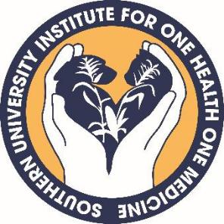

**For more information contact:**

Dr. Renita W. Marshall, DVM, MS

**Telephone**: (225) 771-0252

**Email**: [renita_marshall@suagcenter.com](mailto:renita_marshall@suagcenter.com)

or Dr. Dana Pollard, PhD, MS

**Telephone**: (225) 771-3505

**Email**: [dana_pollard@suagcenter.com](mailto:dana_pollard@suagcenter.com)

Southern University Agricultural Research and Extension Center and the College of Agricultural, Human and Environmental Sciences is an entity of the Southern University System, Orlando F. McMeans, Chancellor-Dean, Dennis J. Shields, System President, Myron K. Lawson, Chairman, Board of Supervisors. It is issued in furtherance of the Cooperative Extension Work Act of December 1971, in cooperation with the U. S. Department of Agriculture. All educational programs conducted by the Southern University Agricultural Research and Extension Center and the College of Agricultural, Human and Environmental Sciences are provided to people of all ages regardless of race, national origin, or disability © 2024 SU Ag Center.