**Heartworm Disease in Baton Rouge, Louisiana: A Critical Look**

**Niko Grymes-Hill*, D. Pollard, R. Marshall**

**Southern University A&M College, Baton Rouge, LA 70813**

## C:\Users\dana.pollard\AppData\Local\Microsoft\Windows\INetCache\Content.MSO\9788B1D.tmp cid:e5159116-8dc6-4eab-8d4a-599816e70b63

*“Grow jAGs”*

*“Linking Citizens of Louisiana with Opportunities for Success”*

**Heartworm disease**

Heartworm disease is a severe and potentially fatal condition affecting pets throughout Louisiana and the rest of the U.S. This disease is caused by a parasitic worm known as *Dirofilaria immitis*, and is mosquito-borne. Adult heartworms can live for 5-7 years in dogs and up to 2-3 years in cats.

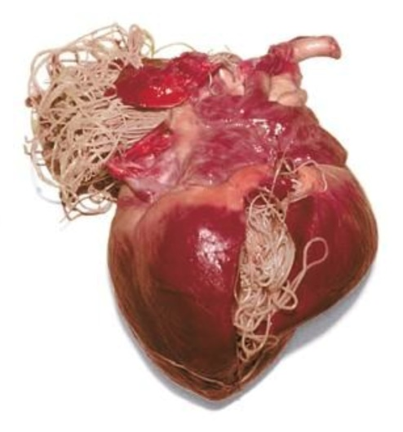

Mosquitoes thrive in a warm and humid climate, creating an environment favorable to the spread of heartworm disease. The proximity to bodies of water and a large population of wildlife reservoirs, such as coyotes and foxes, contribute to the prevalence of the disease.

**Lifecycle of Heartworms**

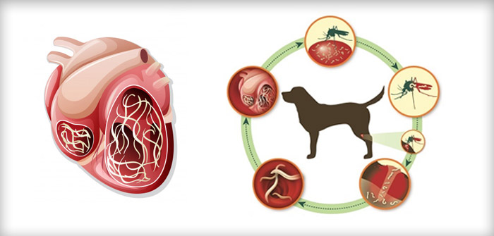

1. Mosquito bites an infected animal and ingests the microfilariae (heartworm larvae).

2. Inside the mosquito, the larvae develop into infective stage larvae.

3. When the infected mosquito bites another animal, the larvae is transmitted.

4. The larvae mature into adult heartworms in the animal's body, residing in the heart, lungs, and associated blood vessels.

**Impact on Health**

Once mature, heartworms can cause significant damage to an animal's cardiovascular system. Symptoms in dogs may include a mild persistent cough, reluctance to exercise, fatigue after moderate activity, decreased appetite, and weight loss. Cats may exhibit asthma-like attacks, periodic vomiting, lack of appetite, or weight loss. If left untreated, heartworm disease can lead to severe lung disease, heart failure, other organ damage, and even death.



**Prevention and Treatment**

Prevention is the most effective approach against heartworm disease. Veterinarians recommend year-round preventive medications, which are available in various forms, such as pills, ointments, and injections. Regular testing for heartworms is also crucial, as early detection can greatly improve the outcome of treatment.

Treatment for heartworm disease is available but can be costly and complex, especially in the later stages of the disease. It typically involves an FDA-approved drug that kills adult heartworms, administered under the supervision of a veterinarian. Treatment protocols may vary and can pose risks; hence, prevention is always preferable.



**Funding Source:** The USDA 1890 Evans-Allen Program project accession no. 1021121 from the USDA National Institute of Food and Agriculture.



**For more information contact:**

Dr. Renita W. Marshall, DVM, MS

**Telephone**: (225) 771-0252

**Email**: [renita_marshall@suagcenter.com](mailto:renita_marshall@suagcenter.com)

or Dr. Dana Pollard, PhD, MS

**Telephone**: (225) 771-3505

**Email**: [dana_pollard@suagcenter.com](mailto:dana_pollard@suagcenter.com)

Southern University Agricultural Research and Extension Center and the College of Agricultural, Human and Environmental Sciences is an entity of the Southern University System, Orlando F. McMeans, Chancellor-Dean, Dennis J. Shields, System President, Myron K. Lawson, Chairman, Board of Supervisors. It is issued in furtherance of the Cooperative Extension Work Act of December 1971, in cooperation with the U. S. Department of Agriculture. All educational programs conducted by the Southern University Agricultural Research and Extension Center and the College of Agricultural, Human and Environmental Sciences are provided to people of all ages regardless of race, national origin, or disability © 2024 SU Ag Center.