On Wednesday, September 14, 2022, the Scotlandville CDC class participants attended in a nutrition education/ food demonstration class by COE Center’s Program Coordinator Brittany Howard. The topic of the evening was Fad Diet Fact or Fiction. Participants were able to identify Fad Diets and share their past experiences using those diets as a way of losing weight. We were able to break down the trends seen in participants that wanted to make lifestyle changes. With that information we identified healthier tactics to use in the future. The class ended with participants making their own fruit smoothies. A super convenient way to consume daily requirement of fruits and vegetables while also nourishing the body with many essential vitamins and minerals.

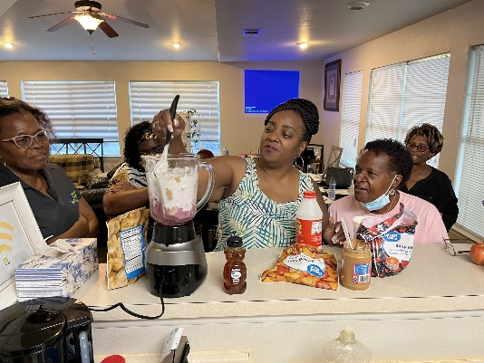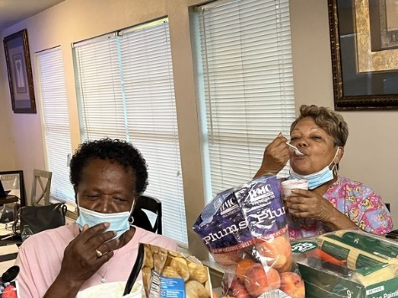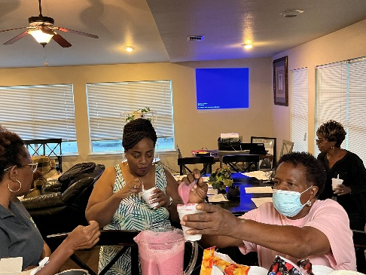

Wednesday, September 7, 2022, the Scotlandville CDC class participants attended in a nutrition education/ food demonstration class by COE Center’s Program Coordinator Brittany Howard. The topic of the evening lesson was Meals to Menus: Straight Ahead on a Healthy Way Drive. The participants were able to identify steps in planning and preparing a healthy meal by planning for everything in advance that leads to more control over one's food choices and allowing participants to better save On time and money as well. Also tips to modify everyday recipes and the importance of understanding the nutrition facts label was discussed. The class ended with a food demonstration on the preparation of Lettuce Wraps. They were able to create a simple healthy taco with ground turkey meat, that left them wanting more.
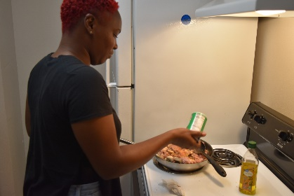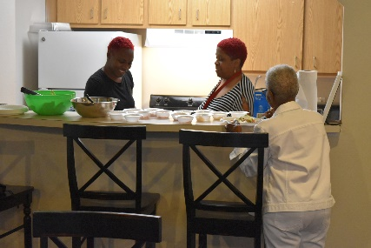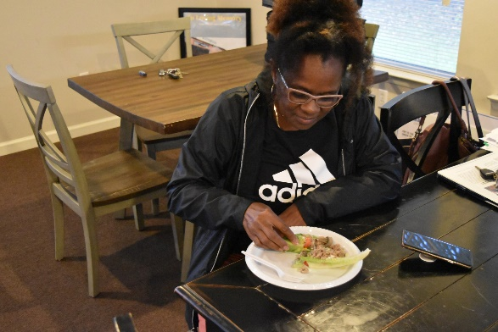

On Wednesday, August 31,2022, our Scotlandville CDC class participated in a class with Dr. Veronica Manrique of Southern University Ag Research Department Entomologist. Dr. Veronica gave an in-depth presentation on garden insects. Being familiar with the types of insects is a major tool in maintaining a successful garden. Many beneficial insects are overlooked and often terminated. Dr. Veronica’s knowledge was impactful and gave a new perspective. Getting acquainted with insects can be a daunting task, but with patience and growth it can turn into a beautiful relationship.
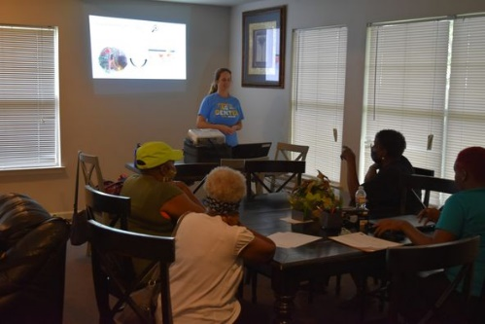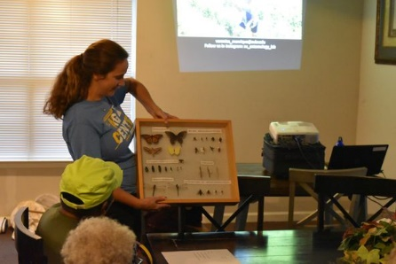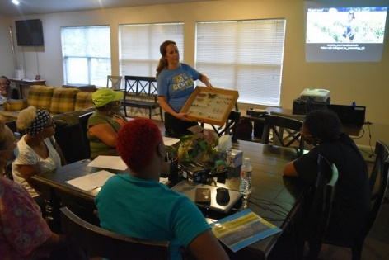

On Wednesday, August 17, 2022, our Scotlandville CDC class participated in a class with Program Leader/Trainer of the Sustainable Urban Agriculture Certification Program Dr. Marlin Ford. Dr. Ford gave a hands-on presentation on several types of Ponic systems which included aquaponics, hydroponics, and aeroponics. The participants were able to help replenish the hydroponic system that was provided to the Scotlandville CDC by the Center of Excellence program. The class replenished the system with collard greens, tomatoes, and bell peppers. The women were eager to get their hands dirty and worked well with the task at hand.

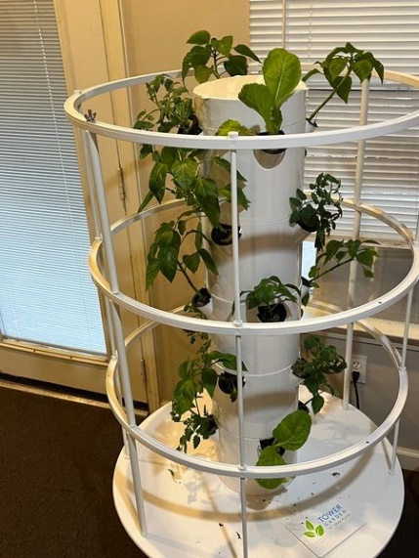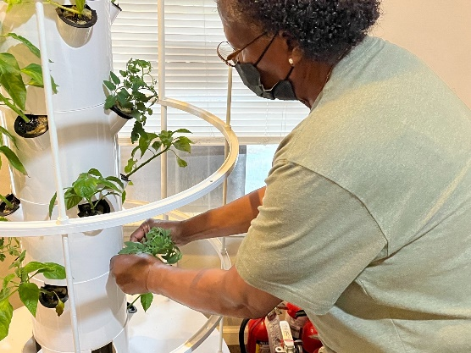
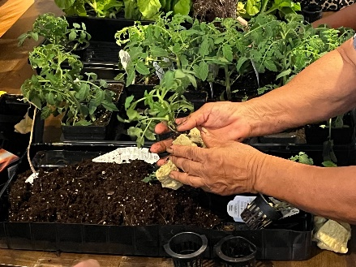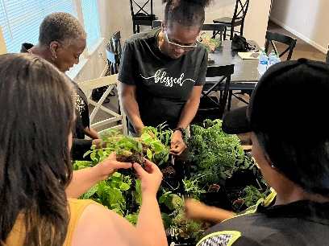
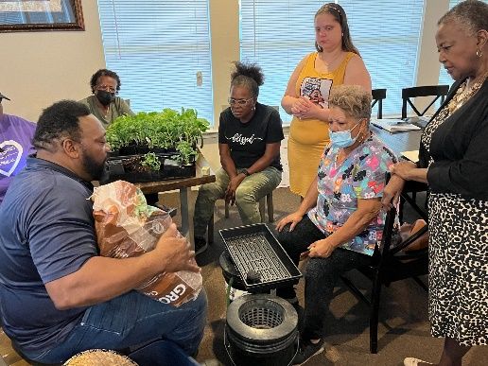

Thursday, August 12th, our Scotlandville CDC class participated in a class with Senior Research Associate Program Trainer Mila Berhane. She gave a detailed presentation on a variety of herbs that can be impactful in daily tasks. Participants were able to learn key steps in starting an herb garden and the best conditions for them to thrive. Ms. Mila brought a surplus number of herbs for participants to smell and identify. Everyone was excited about learning new ways to use herbs outside of kitchen. Such as a catnip herb that can double as an insect repellent. All participants were excited about this week's topic and to come out next week to welcome a new lesson.
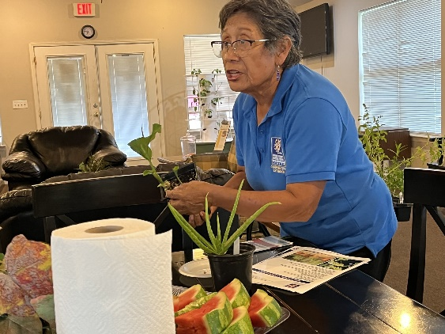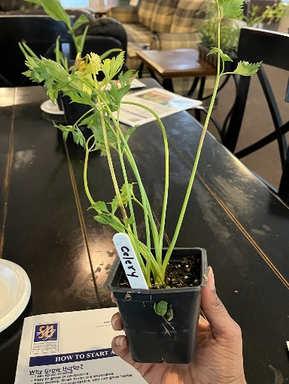
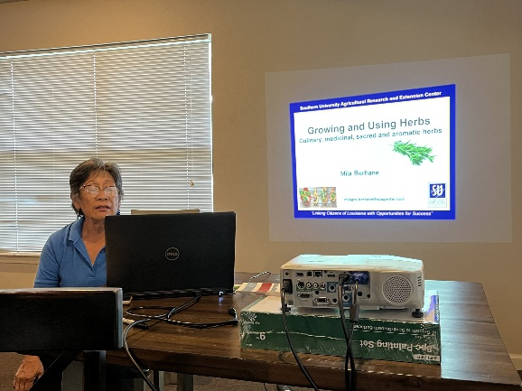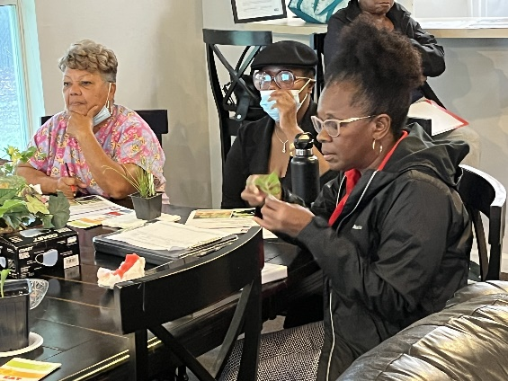

Scotlandville CDC
Topic: Behavior Change: Making it Happen
Date: August 10, 2022
Participants attending Center of Excellence for Nutrition, Health, Wellness and Quality of Life at SUAREC nutrition education class, appreciated the presentation on the importance of changing one's overall behavior to acquire and maintain positive healthy behaviors. Our presenter, Ms. Kelly introduced the idea of SMART Goals, allowing listeners to create and identify realistic goals. The group was able to practice transforming habits with a food demonstration over on the topic of vegetables. They participated in a hands-on food demonstration where they prepared Buffalo Cauliflower tacos. The tacos consisted of air fried cauliflower tossed in buffalo sauce with an avocado crema slaw. Participants were surprised that they enjoyed the recipe, and they were not affected by the absence of meat.
